Threats and Countermeasures – Lecture 8 Defense Evasion
Lessons Learned – Project 1
Lessons Learned – Project 2
- 3 different ways to get root access
- Suid bit
- Cron job
- Alice had access to run sudo
- Crack passwords in hashes
Penetration Testing Process
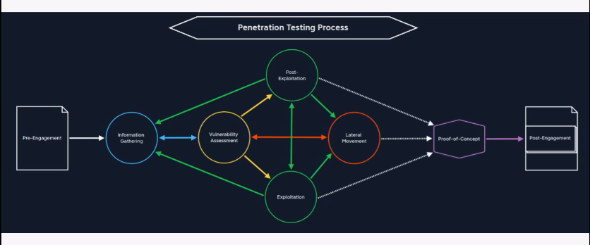
Attacker Mindset
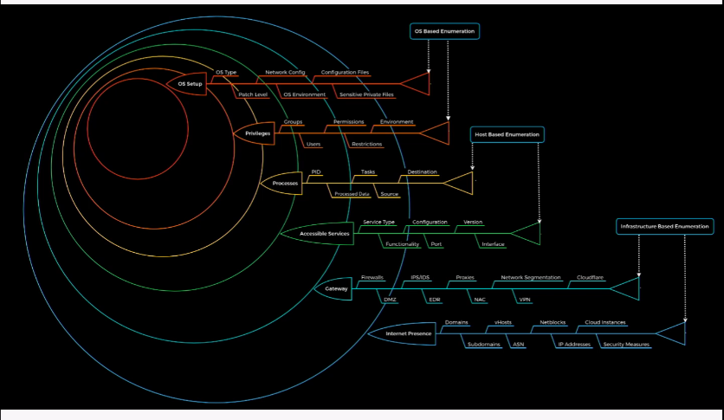
Next stage of MITRE ATT&CK – Defense Evaluation
- Goal: avoid detection during compromise
- Ex:
  - Reconfigure ENV
  - Deactivate host-based defenses
  - Suppress own artifacts (data/code/etc)
Common Defenses
- Anti-Virus
  - Heuristic – and Signature-based detection of unwanted apps/code/malware
  - Automated OS interference to remove and/or quarantine
Common Host-based Defenses
- Anti-Virus
- Network IPS
  - Monitor network traffic for specific heuristics
  - Automated network interference to block interaction
- Filesystem Watchdog
  - Monitors specific filesystem locations for state-changes
  - Automated alerts on contents/metadata changes
- Aggregated logs/alerts
  - Stream logs/alerts/etc. to remove location for independent storage
  - Allows trend-detection
But, I have tools
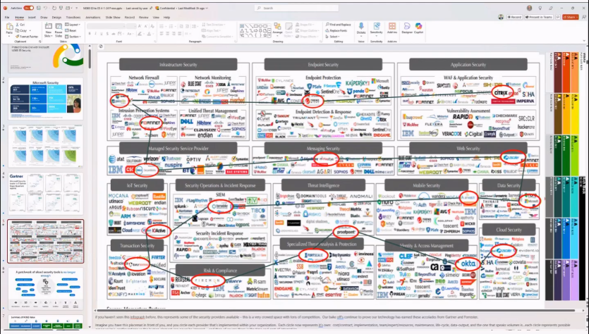
Tools << Security Principles
- Tools increase complexity
- Give false sense of security
- Understanding the data behind the tools is more important and how to evade them
Hands-On Activity
- Banning IPs
Bypass: Deactivate defenses
Bypass: Hide
- All defenses rely on ability to see the artifacts of maliciousness
Don’t Disrupt Usage
- People start looking when things seem “off”
Masquerading Tools/Services
- ps aux
OS “protection features”

